

Department of Computer Engineering
Cairo University
Faculty of Engineering

ELC 3252 – Spring 2025
Digital Communications

Assignment #1
Quantization

Submitted to
Dr. Mai Badawi
Dr. Hala
Eng. Mohamed Khaled
Submitted by

Name | Sec | BN
Ahmed Hamed Gaber | 1 | 3
Somia Saad El-Shemy | 1 | 26

Contents
Part 1. Uniform Scalar Quantizer 4
Part 2. Uniform Scalar De-Quantizer 4
Part 3. Testing on Deterministic Input (Ramp Signal) 5
Comment: 5
Part 4. Testing on Uniform Random Input 6
Comment: 6
Part 5. Testing on Non-Uniform Random Input (exponentially distributed) 7
Comment: 7
Part 6. Non-Uniform Quantizer Using μ/mu Law 8
Comment: 8

Figures
Figure 1 input-output of quantizer/de-quantizer 5
Figure 2 SNR vs Number of bits on a uniform random input 6
Figure 3 SNR vs Number of bits on an exponentially distributed input 7
Figure 4 SNR vs Number of bits for different mu-Law Parameters 8

Part 1. Uniform Scalar Quantizer

- First step was to shift the input signal by this offset:
(m * delta / 2) - xmax , where delta is the step size
- Then we floored it to the nearest level
- Finally we clip the signal from 0 to L-1

Part 2. Uniform Scalar De-Quantizer

- We reconstructed the signal according to this formula:
deq_val = (q_ind + m / 2 + 0.5) * delta – xmax
- The term (q_ind + m / 2 + 0.5) adjusts the quantized index to the center of the quantization interval.
- Then multiplying by delta scales it back to the appropriate range.
- Subtracting xmax shifts the value back to the original signal's range.
- Quantizer and De-Quantizer are made using scalar division and independent of the bitrate

Part 3. Testing on Deterministic Input (Ramp Signal)

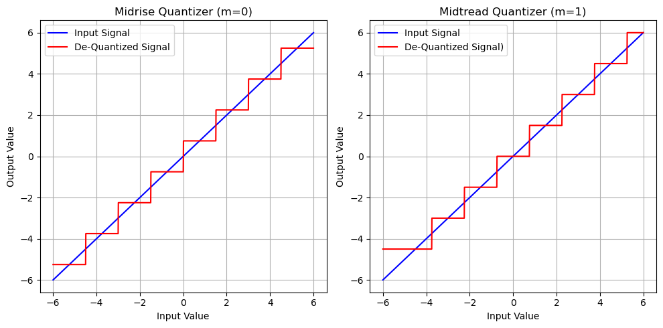
Figure 1 input-output of quantizer/de-quantizer

Comment:
Number of bits = 3, signal maximum = 6
After de-quantization we can see that the de-quantized signal is aligned with input signal which means it is nearly somehow reconstructed.
Midrise quantizer shows the signal to be rising at zero, and the midtread quantizer showe the signal to have zero value around zero.

Part 4. Testing on Uniform Random Input
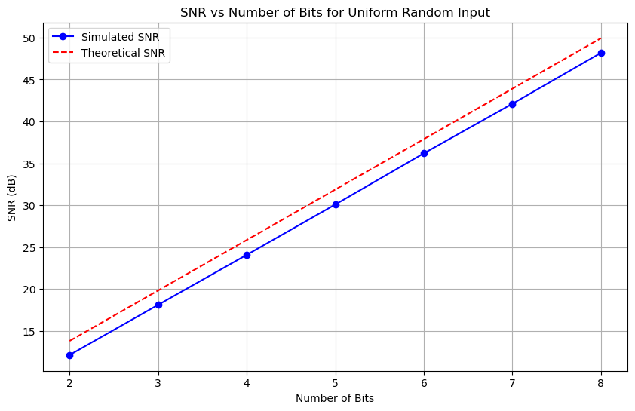

Figure 2 SNR vs Number of bits on a uniform random input

Comment:
The graphs shows that as the number of bits increases, the Signal-to-Noise Ratio improves. The simulated SNR closely follows the theoretical SNR, which indicates an accurate simulation, but a small deviation is observed, which could be due to calculation errors and because of the finite sample.

Part 5. Testing on Non-Uniform Random Input
(exponentially distributed)
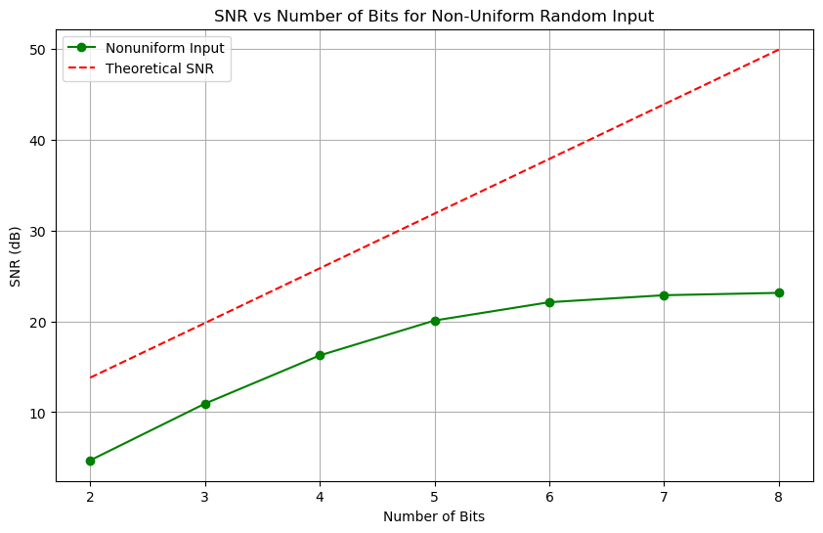

Figure 3 SNR vs Number of bits on an exponentially distributed input

Comment:
The SNR for the non-uniform input grows slower than the theoretical SNR, especially for higher number of bits. This is expected due to the quantization noise dependency on the input distribution. Since exponential distributions have non-uniform concentration of values, the uniform quantization leads to larger errors in denser regions. The SNR curve starts to saturate after reaching 6 bits.
Clipping of the quantized indices is the main reason behind that.

Part 6. Non-Uniform Quantizer Using μ/mu Law

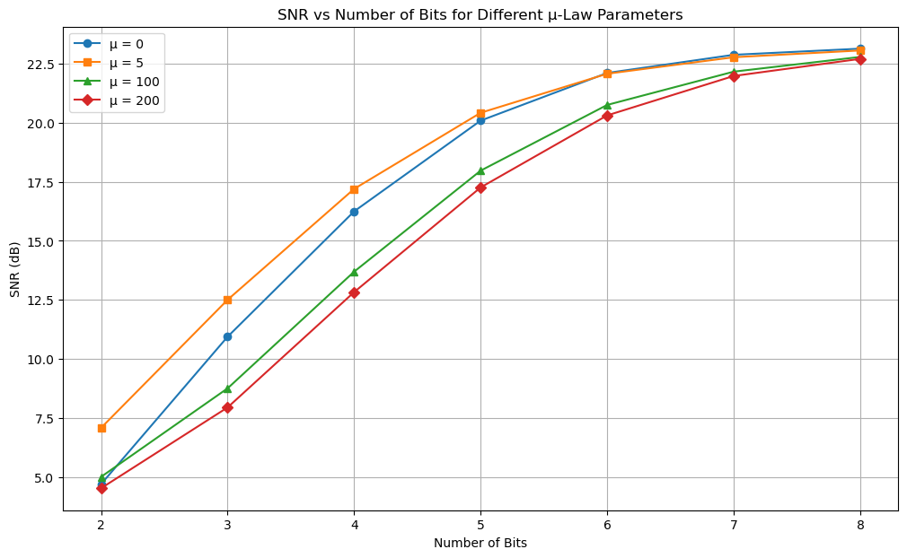
Figure 4 SNR vs Number of bits for different mu-Law Parameters

Comment:
As μ increases, the SNR at small number of bits (2-4 bits) improves significantly, especially for moderate values of μ → μ = 5 is much better than μ = 0
The compression/expansion of the input signal reduces the quantization error, it acts as if it linearize the signal.
As μ becomes very large (μ=200), the quantization error increases. This is because excessive compression of the signal leads to higher distortion when expanded back.
All this concludes that you better choose moderate values for μ, like 5 for example.

